A187-Afr-Egy-Ushabti-26th Dynasty-Ex Flinders Petrie

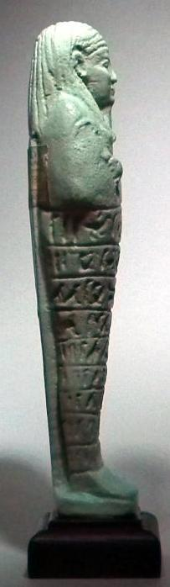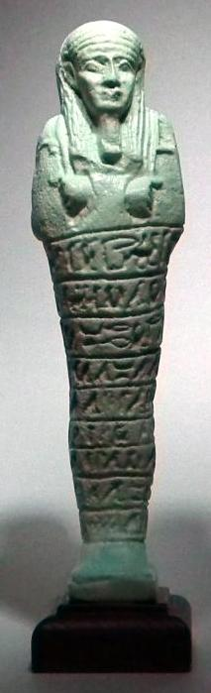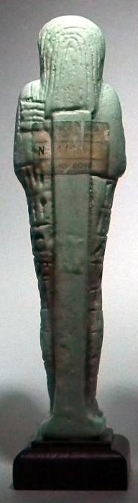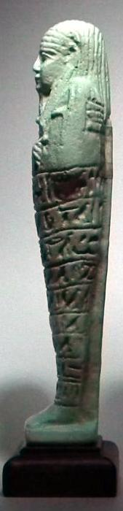

Formal Label: Ushabti Figure, 26th dynasty

**Display Description**: Superb pale blue-green color, a long striated wig, a plaited beard and is inscribed with the Saite version of chapter six of the *Book of the Dead* in nine horizontal registers of hieroglyphs. It was believed that the recitation of this text would bring such figures to life to carry out the agricultural duties demanded of its dead master in the afterlife. In readiness, the piece carries a pick, an adze and behind its left shoulder, a seed basket.

Accession Number: A187

LC Classification: DT62

Date or Time Horizon: 26th Dynasty

Geographical Area: Sais, Egypt

Map, GPS Coordinates: 30.96650 30.76751, 30º57'59.41" N 30º46'3.02" E

 

Fig. Left. Sais on the Nile after http://latitude.to/lat/30.96606/lng/30.76785. Fig. Sais reconstructed according to Jean-Claude Golvin, http://jeanclaudegolvin.com/sais-2:

Cultural Affiliation: 26th Dynasty

Medium: Blue faience

Dimensions: H 6.5 inches (165 mm).  Plinth: 17.79 mm; 0.7 in Weight: 167 gm; 5 7/8 oz with plinth.

Provenance: ex Blanchard’s, Cairo, Egypt; then Flinders Petrie, 1926. An intact and very rare museum quality example complete with attached labeling and invoice addressed to Flinders Petrie at the Semiramis Hotel, Cairo 1926.

**Condition:** original.

**Discussion:**

Psamtik I, ruled 664–610 BCE, commanded a loose confederation of twelve Egyptian territories, based on the traditional nomes or territories (spAt, in Egyptian), and the rise of Psamtik I in power, establishing the Saitic Dynasty, which is recorded in Herodotus's *Histories* (Bk II: ll. 151–157). Twenty local princelings were appointed by Esarhaddon (king of the Neo-Assyrian Empire who reigned 681 – 669 BCE) to govern Egypt. In the tomb of Seti I, over eight hundred Ushabti figures were found scattered around the carcass of a slaughtered bull.

**References:**

Aubert, J.-F. et L. Aubert. 1974. *Statuettes Egyptiennes: Chaouabtis, Ouchebtis.* Paris, 1974.

Janes, Glenn. 2002. *Shabtis. A Private View, Ancient Egyptian Funerary Statuettes in European Private Collections.* Paris: Cybèle.

Newberry, Percy E. 1930-1957. *Funerary Statuettes and Model Sarcophagi.*  Le Caire: Impr. de l'Institut français d'archéologie orientale.

Schneider, Hans D. 1977. *Shabtis - An Introduction to the History of Ancient Egyptian Funerary Statuettes. With a Catalogue of the Collection of Shabtis in the National Museum of Leiden*. (3 volumes, Leiden: Rijksmuseum van Oudheden Te Leiden.

Schlögl, Hermann and Andreas Brodbeck. 1990. *Ägyptische Totenfiguren aus öffentlichen und privaten Sammlungen der Schweiz.* Orbis Biblicus et Orientalis, Series Archeologica, 7. Göttingen, Vandenhoeck & Ruprecht; Freiburg Schweiz, Univ

.

